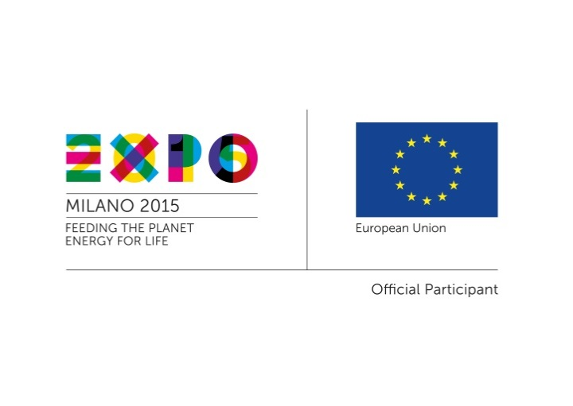
Expo 2015: the European Commission promotes investment and business opportunities among European and Latin American companies

The third of the EU-Third Country Events dedicated to Latin America and Caribbean will take place on 12 and 13 June, 2015 in Milan at Palazzo delle Stelline.

In the framework of the Universal Exposition, Expo Milano 2015, from May 1st to October 31st 2015, the European Commission organizes a series of events dedicated to the central theme of Expo 2015 “Feeding the Planet, Energy for Life”
In particular, seizing the occasion of Expo 2015, a global event with the presence of 145 Countries and 3 International Organizations, the Directorate General for Internal Market, Industry, Entrepreneurship and SMEs (DG GROW) of the European Commission is promoting a series of high-level events in Milan to boost the European SMEs system and facilitate their internationalization.
The aim of the EU-Third Country events is to support the development and competitiveness of European companies and to facilitate their access to strategic markets.
EU-Third Countries events are organized in collaboration with the Enterprise Europe Network, the network created by the European Commission to support SMEs and Promos – Special Agency of the Milan Chamber of Commerce. Events include free-of-charge Business-to-Business Meetings among European companies and those from targeted Third Countries and Regions. Companies operating in specific sectors related to Expo themes are invited to participate: agro-food industry, packaging, bio-economy, creative industry, space applications to agriculture, and resources management.
Partners of the initiative are the European Commission Representative Office in Milan, the Lombardy Regions, Assolombarda, CNA and AICE.

The EU – Latin America and Caribbean (CELAC) will be structured as follows:
- A first session on 12th June morning (see the annexed agenda) will present the framework of the policies and tools to improve the business environment, and to promote the industrial cooperation, investments and trade between the EU and CELAC.

- On 12th June late morning, Business-to-Business meetings will take place among European and Latin American companies from the following sectors: agro-food, food design, wine and food tourism, technologies for agriculture.

- On 13th June a visit to Expo is organized by the European Commission.
Companies operating in the abovementioned industries and willing to participate on the dates dedicated to CELAC, including business meetings, are invited to register on the website: https://www.b2match.eu/expo2015-creativityindustry. Companies have to cover their travel expenses.
Next events will be with Japan (10-11 July), Sub Saharan Africa (18-19 September), South East Asia (29-30 September), United States and Canada (5-6 October). For further information: www.euexpo2015.talkb2b.net

